Selkirk, Bob
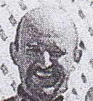
Son of Andy Selkirk. Graduated from Dwellingup Cadet School 1970. Commenced as Forests Guard 1971 at Collie. Worked in aerial ignition team for many years. On National Service in 1971. In 1973 transferred from Mundaring to Como Fire Control. Senior Forester at Harvey in 1988. With Management Audit Branch in 1990s. With Forest Production Commission in 2000s. Operations Auditor FPC Bunbury 2001.

